# Media Analysis - ‘I am not here to take your job,’ ChatGPT tells Frankly Speaking host

## Short Summary

ChatGPT, an AI language model developed by OpenAI, discusses its role in generating human-like text for applications like translation, information access, and task automation, while acknowledging concerns over privacy, bias, job displacement, emphasizing the need for responsible use and ethical regulation.

## Summary

ChatGPT's responses demonstrate its ability to understand, interpret, and generate human-like text based on the input it receives. Here are some key points from ChatGPT's interview with Arab News:  
1. **Understanding and Resolving Issues**: ChatGPT emphasizes the importance of dialogue and understanding in addressing underlying issues rather than assigning blame or seeking a single answer. This aligns with its role as a tool designed to enhance communication between people from diverse backgrounds.  
2. **Responsible AI Use**: The AI expresses cautious optimism about its potential impact on humanity, stating that the choice to use and regulate it will largely depend on how developers, policymakers, and users approach this technology responsibly. This reflects a recognition of both the benefits and risks associated with AI development.  
3. **Naturalness and Sophistication in Text Generation**: ChatGPT acknowledges that improving the naturalness and sophistication of AI-generated text will likely be a key area for future advancements. It suggests focusing on developing more diverse language, incorporating emotion and personality into responses, and enhancing contextual understanding to provide personalized and relevant answers.  
4. **AI Development Opportunities**: The interview reveals that organizations like OpenAI are continuing to develop AI technologies such as GPT-4, which aims to improve the accuracy of text responses from both image and text inputs. This advancement is expected to contribute significantly to AI language models in the future.  
5. **Ethical Considerations**: ChatGPT acknowledges that developers, policymakers, and users should work together to address ethical concerns surrounding AI technology, including privacy issues, bias, and potential job displacement. This underscores the responsibility of all stakeholders in shaping the positive impact of AI on society.  
In summary, ChatGPT highlights its role as a tool for facilitating communication and enhancing understanding between people from different backgrounds, while also emphasizing the need for responsible use and ethical considerations in the development and application of AI technology.

## Question 1:

How do the media in this article frame the public discussion about ChatGPT? Are there certain **metaphors** that keep cropping up?

The media frames the public discussion about ChatGPT through metaphors such as 'AI language model', 'a tool that can be used for a wide range of applications', and 'cautious optimism'. These phrases highlight the technological advancement aspect, emphasize its versatility, and express cautiousness regarding potential risks.

## Question 2:

Which role does or might the Arabic World play in the development of Artificial Intelligence? Answer with 'Not mentioned' if not applicable.

Not mentioned

## Question 3:

Which use cases of Artificial Intelligence are helpful for the Arabic world based on this article?

1. Language Translation As an AI language model, ChatGPT can facilitate communication and translate between languages, aiding in intercultural understanding and global collaboration. This can significantly benefit countries where English is not widely spoken.

## Question 4:

What is the final message of the article that the author wants to convey? Keep your answer short and precise!

AI has potential for significant positive impact but requires responsible use to address concerns about privacy, bias, and job displacement.

## Sentiment

The sentiment is <0>

neutral

## Entities

Focus Effort Near Future Area Focus Improve Naturalness Sophistication, Saudi Arabia Say Chatgpt Provide News Analysis Local Regional International Event Reputation Provide Accurate Timely Comprehensive News Coverage, Innovation Evolution Field Year, Initial Investment Firm Billion Billion Windows Maker, Task Automate Ai, Say Response Base Solely, Sam Altman, Focus Develop Ai Model Context, Microsoft, Katie Jensen, Manner Chatgpt Say Important, Kalty Jansenv, Generative Ai Live Reputation Produce Human Like, Https Medium Arab News Country, Ai Facilitate

## Topic Clusters

### Cluster: technological_advancements

ChatGPT, AI applications in everyday life

### Cluster: Artificial_Intelligence_in_society

Societal effects of AI, Ethical considerations of AI

## Word Clouds

### Wordcloud of content

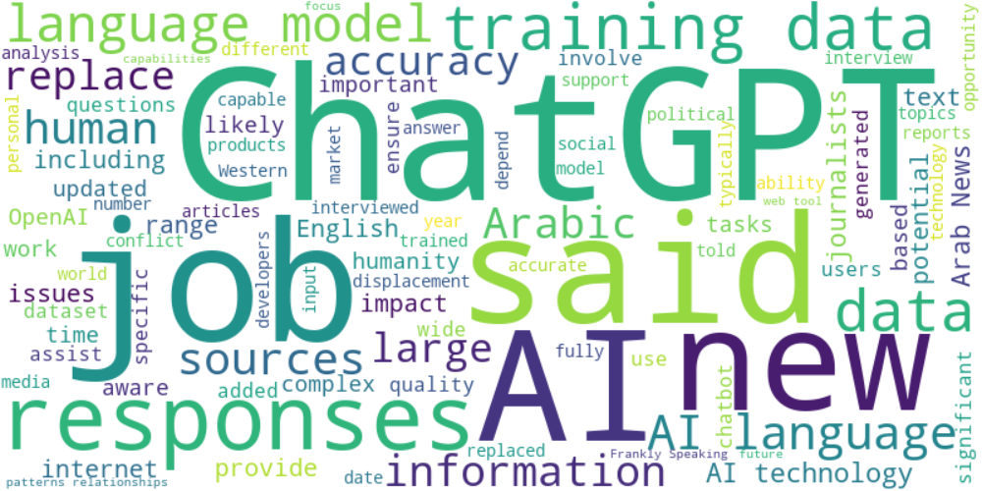

Top 10 words:

- AI: 37  
- data: 28  
- ChatGPT: 26  
- language: 24  
- training: 17  
- said: 17  
- responses: 15  
- job: 11  
- technology: 11  
- human: 10

### Wordcloud of summary

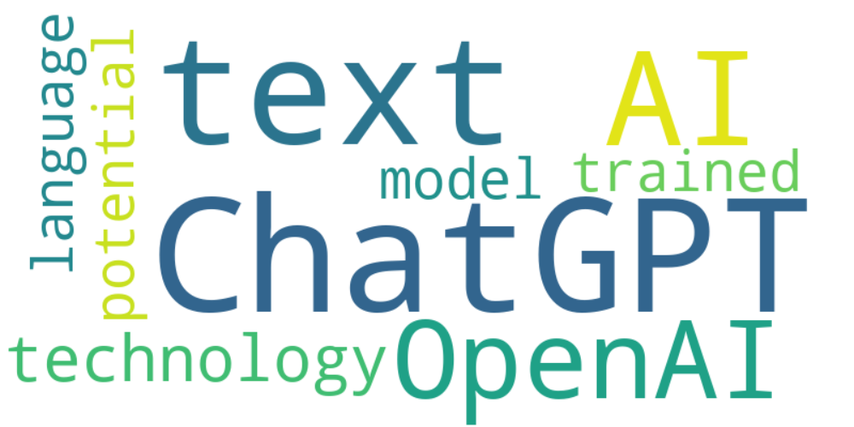

Top 10 words:

- AI: 10  
- ChatGPT: 6  
- text: 4  
- responses: 3  
- understanding: 3  
- technology: 3